Innovation in the business sector through government policies as a strategic opportunity in Ecuador

Innovación en el sector empresarial desde las políticas gubernamentales como oportunidad estratégica en Ecuador

Egas Moreno Fanny Graciela
Salazar Tuárez Emma Angelina*
Cheme Hernández Jair Paul*
Masapanta Delgado Marelyn Nicole*

ABSTRACT
Innovation has become a strategic element for the competitiveness and sustainable development of nations. However, structural limitations persist in Latin America, including low investment in research and development, technological dependence, and institutional discontinuity, factors that restrict the consolidation of stable innovation ecosystems. Ecuador acutely reflects these tensions: despite having legal frameworks and programs such as InnovaEcuador, their impact has been limited by a lack of funding and inter-institutional coordination. The objective of this article was to analyze government documents and policies related to innovation in the business sector in order to identify priority areas for action and strategic opportunities to strengthen the innovation ecosystem in Ecuador. A qualitative, descriptive-analytical documentary design was used, based on a systematic review of national regulations, reports from international organizations, and recent scientific literature. The analysis included the construction of comparative tables, heat maps, and semantic networks, which allowed the information to be organized into three levels: global, regional, and national. The results show that the main weaknesses are concentrated in the institutional and economic dimensions, while the most promising opportunities are in the business and socio-environmental spheres. It is concluded that Ecuador needs to articulate long-term policies, with sustained financing and coordination mechanisms between the state, academia, and business, to transform innovation into an effective driver of competitiveness, inclusion, and sustainability.
Keywords: innovation, public policy, competitiveness, Ecuador

RESUMEN
La innovación se ha consolidado como un elemento estratégico para la competitividad y el desarrollo sostenible de las naciones. Sin embargo, en América Latina persisten limitaciones estructurales, entre ellas la baja inversión en investigación y desarrollo, la dependencia tecnológica y la discontinuidad institucional, factores que restringen la consolidación de ecosistemas de innovación estables. Ecuador refleja de manera aguda estas tensiones: pese a contar con marcos legales y programas como InnovaEcuador, sus impactos han sido limitados por la falta de financiamiento y de coordinación interinstitucional. El objetivo de este artículo fue analizar documentos y políticas gubernamentales relacionadas con la innovación en el sector empresarial, con el fin de identificar áreas prioritarias de acción y oportunidades estratégicas que fortalezcan el ecosistema de innovación en Ecuador. Se empleó un diseño documental de enfoque cualitativo y alcance descriptivo-analítico, a partir de la revisión sistemática de normativas nacionales, informes de organismos internacionales y literatura científica reciente. El análisis incluyó la construcción de cuadros comparativos, mapas de calor y redes semánticas, lo que permitió organizar la información en tres niveles: global, regional y nacional. Los resultados muestran que las principales debilidades se concentran en las dimensiones institucional y económica, mientras que las oportunidades más prometedoras se ubican en los ámbitos empresarial y socio-ambiental. Se concluye que Ecuador requiere articular políticas de largo plazo, con financiamiento sostenido y mecanismos de coordinación entre Estado, academia y empresa, para transformar la innovación en un motor efectivo de competitividad, inclusión y sostenibilidad.
Palabras clave: innovación, políticas públicas, competitividad, Ecuador

INTRODUCTION
For centuries, progress was a distant promise, an idea reserved for visionaries and utopians. Today, however, it presents itself as a wave that breaks without warning, because innovation is no longer a luxury reserved for wealthy countries or a buzzword at international conferences; it has become a strategic necessity, the fine line that separates nations that are moving forward from those that remain stuck in the last century. It is no longer a matter of producing more, but of producing better—with creativity, responsibility, and an eye toward the challenges ahead, not just the urgent needs of the present (Organization for Economic Cooperation and Development [OECD], 2021).
In the countries that lead the global economy, innovation is part of the institutional DNA, where digitalization, artificial intelligence, and the energy transition are neither threats nor passing fads, but rather integrated development platforms with a long-term vision. South Korea, Finland, Singapore, and Germany have succeeded in turning science and technology into drivers of well-being. There, research is funded seriously, universities collaborate with businesses, and public policies are designed with a compass that does not change every four years (Brás, 2024; Li, 2023). Innovation does not depend on the mood of the minister in office, but rather on structures that transcend governments.
Latin America, on the other hand, seems trapped in a perpetual paradox: while talk of innovation abounds, concrete action is scarce. Consequently, strategies are announced with enthusiasm but rarely sustained over time. Investment in research and development is marginal (barely 0.5% of regional GDP compared to 2.5% in developed economies), universities are disconnected from the business world, and dependence on foreign technology continues to set the limits of what change is possible (Economic Commission for Latin America and the Caribbean [ECLAC], 2020). Meanwhile, the world is advancing at breakneck speed, and the region watches—sometimes with resignation, sometimes with hope—as others lead the processes that will define the 21st century.
Ecuador is no exception to this pattern; in fact, it embodies it with particular starkness. In recent years, programs such as InnovaEcuador have been created, and laws have been passed to promote science and coordinate initiatives to support entrepreneurship. However, most of these efforts have begun with enthusiasm and died out due to exhaustion. The reason is well known but rarely acknowledged: a lack of political continuity, institutional fragility, and an obsession with the immediate prevent public policies from maturing (World Bank, 2021; GIZ, 2023). Innovation takes time, and time in Ecuadorian politics seems like an endangered species.
The country’s companies operate in an environment hostile to innovation, and although there is a talented workforce with creative capacity, the structural conditions are adverse; many companies lack access to financing, technological infrastructure, or collaborative networks with research centers. Relationships with universities are weak, and organizational culture often prioritizes survival over experimentation, creating a vicious cycle in which innovation becomes an inaccessible luxury—more aspiration than reality, more slogan than strategy (Fernández-Sastre, 2024).
Despite this bleak outlook, there are also signs of hope: in some sectors, incubators, public funds, and international partnerships have emerged, offering a glimpse of new dynamics. Some entrepreneurs have managed to develop value-added products, enter global markets, or adopt emerging technologies. However, these cases are usually exceptional, and their success is not enough to transform the system. What is lacking is not talent, but a conducive environment that rewards risk-taking, supports experimentation, and provides a safety net for failure. Without that, innovation will remain a solitary feat, not a collective policy (World Bank, 2023).
The challenge, then, is to build a coherent ecosystem capable of bringing together academia, the government, and the private sector around shared objectives; it is not enough to create programs or enact laws; it is necessary to establish a common national vision, with long-term goals and evaluation mechanisms that ensure continuity. Innovation must cease to be a technical issue reserved for experts and become a public matter, debated with the same seriousness with which employment, health, or security are discussed. Because, at its core, innovating is also a way to guarantee rights (Hidrobo-Morales et al., 2024).
Consequently, analyzing existing documents and policies becomes an essential step—not to compile a bureaucratic inventory, but to identify gaps, inconsistencies, and potential. Reviewing what has been designed and what has remained on paper allows us to understand the root causes of stagnation, but also to glimpse possible paths forward. This exercise requires a critical and constructive perspective; it is not merely a matter of pointing out what does not work, but of imagining what could be achieved if bolder and less reactive decisions were made (Álvarez et al., 2024).
In this way, innovation is not simply about doing new things, but also about leaving behind outdated practices that no longer serve a purpose. It involves transforming the structures that impede change, recognizing that knowledge is an investment rather than an expense, and building trust among stakeholders who have historically operated in a fragmented manner. In this sense, innovation is political in the best sense of the word—a tool for transformation in the service of the common good, a pathway to making development a tangible reality for millions of people (OECD, 2021).
Thus, this article stems from an urgent need: to stop talking about innovation as if it were a magic word that promises everything and delivers almost nothing. More than a theoretical exercise, it is an invitation to take a close look at what public policies are actually doing—or failing to do—for Ecuador’s business ecosystem. This is not about repeating existing analyses or experimenting with trendy concepts; rather, it is about strategically reviewing official documents and government actions intended to promote innovation, in order to identify where the gaps lie, what the bottlenecks are, and what opportunities—with political will and collective intelligence—could become levers for real transformation. The focus is on identifying priority areas for action, but also on bringing to light regions that have historically been treated as footnotes in national development. One such region is the canton of Esmeraldas. Far from the center and off the radar of many institutional agendas, Esmeraldas embodies a powerful paradox: its exclusion has coexisted with a remarkable capacity to generate its own forms of production, adaptation, and creativity.
Therefore, this article is part of a broader effort to rethink the country’s production model—a model that not only needs to be more competitive but also fairer, more diverse, and more sustainable. It is not about importing ready-made solutions but about building paths based on the territory’s actual conditions and innovating; in this sense, it is not merely about applying technology; it is about recognizing local knowledge, coordinating efforts, and ceasing to view marginalized areas as residual spaces—because sometimes, innovation is not found where everyone looks, but rather where no one has been willing to look closely.
Talking about innovation today is no longer a rhetorical luxury or a concession to the technocratic language of international organizations; rather, it has become a strategic necessity for any serious project of economic and social development. However, in many contexts—including Ecuador—the term is repeated insistently in government plans as if its mere mention were enough to modernize deeply entrenched structures. In these cases, innovation runs the risk of becoming a decorative slogan rather than a transformative policy.
International experience has shown that national innovation systems are not mere accessories to development, but rather structural components of competitiveness. Their value lies in the ability to integrate knowledge, technology, and public policy under a long-term vision aimed not only at economic growth but also at institutional resilience and collective well-being (OECD, 2021).
In Ecuador’s case, however, the outlook is far from encouraging; despite some regulatory advances and isolated efforts, structural obstacles persist that prevent the consolidation of a robust innovation ecosystem; institutional weakness, political volatility, and a chronic shortage of funding create an environment that is not conducive to sustaining strategies that, by definition, require time, coherence, and continuity (World Bank, 2021; GIZ, 2023).
In this context, a literature review takes on a significance that goes beyond the technical. It is not merely a matter of gathering data or compiling regulatory inventories, reading policies, comparing regulatory frameworks, or observing their implementation—or lack thereof—but rather of reconstructing patterns, tracing intentions, and, above all, asking whether what is written on paper has actually brought about change on the ground. Whether innovation has left any concrete mark on the productive fabric or whether it remains, as so often, a good idea trapped in decrees (Fernández-Sastre, 2024).
From an academic perspective, critically analyzing innovation policies is not a mere intellectual exercise or a methodological obligation; rather, it is a way of revealing what official reports often conceal—the cracks, the unfulfilled promises, and the institutional silences that drag on with bureaucratic resignation. Although scientific output in Latin America has grown strongly and with merit in recent decades, its impact on decision-making remains tenuous, almost anecdotal; studies exist, but they rarely engage with those who design or implement public policies. This disconnect, rather than an isolated failure, is a symptom of a structurally fractured relationship between knowledge and power (Álvarez et al., 2024).
Reducing innovation to a mere business tool is a limited—if not dangerously reductionist—view; its true scope transcends financial statements and private laboratories. A well-conceived innovation policy can transform social realities, bridge historical divides, and open up concrete possibilities in areas marked by exclusion; it can even become a factor of collective cohesion and resilience in contexts marked by stark inequality and ecological vulnerability, such as Ecuador—a megadiverse country— but also one starkly exposed to extreme phenomena. To conceive of innovation without grounding it in sustainability is not only irresponsible but strategically short-sighted. Insisting on production models that have already proven unviable—both economically and environmentally—amounts to repeating the same mistake with new language. What is at stake is not only competitiveness but the very livability of the future. Integrating sustainability as a guiding principle of innovation strategies should not be an abstract aspiration but a pragmatic obligation. To innovate, in this sense, is also to decide what kind of country we want to build, which territories are prioritized, and which ways of life are considered valuable (UNU-MERIT, 2024).
In Ecuador’s case, the gap between what is promised in terms of public policy and what is actually implemented has left a deep mark, fostering mistrust on the part of the business sector and a progressive weakening of institutional capacities. More than a design problem, what persists is a lack of continuity; Innovation cannot be sustained by interrupted strategies or by partnerships that change with each political cycle. The challenge, therefore, is not merely to create new programs, but to ensure that they endure, that they engage in dialogue with one another, and that they coherently coordinate the government, academia, and the productive sector under shared objectives that are sustained over time (Hidrobo-Morales et al., 2024). Fragmentation has been costly, both in terms of lost opportunities and eroded credibility.
This study is part of that discussion; through a critical analysis of official documents and regulatory frameworks, it seeks to identify key areas for intervention and strategic opportunities to strengthen the innovation ecosystem in Ecuador. The ultimate goal is clear: to contribute to the construction of a development model that is more competitive, more inclusive, and better aligned with the social, economic, and environmental challenges that currently shape the country’s present.
In this context, this manuscript is part of the research project titled “Management and Innovation Strategies for Accounting, Auditing, and Socioeconomic Development from a Holistic Approach in the Province of Esmeraldas, Ecuador”, affiliated with the Luis Vargas Torres Technical University of Esmeraldas, the institution providing academic and administrative support for its implementation.
Innovation is no longer a stylish option or a trendy accessory that companies can adopt when they have resources to spare; it is, increasingly, a matter of survival. In a global landscape as ever-changing as it is unpredictable, the difference between staying afloat and disappearing is not determined by manuals, but by the actual ability to adapt, to imagine different solutions, and to dare to change before change forces you to do so. The transformations brought about by the Fourth Industrial Revolution left no room for complacency; the rules of the game have changed—and they did so without asking permission. On this new landscape, companies that fail to adapt will disappear. Amdouna (2025) sums it up well: technological innovation not only allows for improving processes or reducing costs; it enables us to blaze new trails, gain time, and survive. Innovation, understood in this way, becomes a form of resilience—the ability to stay on your feet when everything is shaking.
But it’s not just about intuition; there is clear evidence. Agazu et al. (2024), through a comprehensive meta-analysis, confirm that companies that commit to innovation—whether by creating new products, reinventing their business model, or incorporating digital tools—have significantly superior competitive performance, not because they do more things, but because they do different things, and because they understand that innovating is not about inventing for the sake of inventing, but about adapting intelligently. What this perspective forces us to recognize is that innovation is neither a one-time event nor a solitary stroke of genius; it is a constant, often invisible process that permeates the day-to-day operations of organizations. It is not about having a great idea, but about having the courage to implement it—to leave behind what once worked and dare to try something new, without guarantees, but with vision. Public policies are not mere regulatory frameworks or declarations of good intentions; they are, in essence, the ground on which companies, research centers, and entrepreneurs attempt—with varying degrees of success—to develop their capabilities. Hence, their role in promoting innovation is more than just important—it is decisive. If the environment does not stimulate, support, and sustain innovative processes, no amount of talent or technology can compensate for it.
Huang (2024) offers a particularly lucid analysis of this dynamic. Through a comparative analysis of national innovation systems, he identifies five fundamental pillars: skilled human resources, adequate infrastructure, accessible financing, a clear institutional framework, and active cooperative relationships. The conclusion is as simple as it is compelling: countries with high-income economies not only possess these elements but have also managed to integrate them coherently; they function as a system, not as isolated parts. In contrast, in many middle-income countries—including several in Latin America—the picture is different: the resources are there, at least in part, but they are scattered; funding is scarce; the institutional framework often changes with the rhythm of political cycles; and cooperation among stakeholders tends to be more declarative than substantive. This lack of coordination is no minor detail; it is, to a large extent, what explains why innovation gaps continue to widen; not due to a lack of ideas, but rather the absence of an ecosystem capable of sustaining them and scaling them up. Innovation, after all, does not flourish in a vacuum. It requires structure, but also vision. And that is where public policies can make the difference between a country that merely survives and one that chooses to move forward.
In Latin America, the situation is more complex. According to ECLAC (2020), national innovation systems in the region have shown progress, but they remain marked by fragmentation and a lack of continuity. Often, public policies are designed with ambitious goals but lack sustained funding or are interrupted by political changes, This creates a climate of uncertainty that directly affects businesses, which perceive innovation as a risky venture rather than a safe opportunity. In Ecuador, this problem is reflected in programs such as InnovaEcuador, which were conceived to stimulate applied research and innovative entrepreneurship but whose implementation was limited by budgetary constraints and a lack of long-term sustainability (World Bank, 2021).
The Latin American experience offers contrasting examples of how innovation policies can be strengthened or weakened depending on how they are implemented. Brazil has stood out for strengthening institutions such as FINEP, which channels funding toward research and development projects. Chile, through CORFO, has designed mechanisms to support entrepreneurship and venture capital that have revitalized its startup ecosystem. According to the OECD (2021), these experiences have enabled both countries to diversify their productive structures and improve their international competitiveness; these cases demonstrate that, when there is institutional continuity and strategic clarity, public policies can become effective drivers of transformation.
In contrast, countries such as Ecuador face greater difficulties in consolidating their innovation efforts. Hidrobo-Morales et al. (2024) found that, in Ecuador’s case, the drivers of innovation stem primarily from cooperation with external sources, highlighting the weakness of national institutions in building an autonomous innovation ecosystem. This situation reflects a structural challenge; While other countries in the region manage to create more stable conditions, Ecuador relies heavily on the private sector and international collaboration, which limits the impact of its public policies and the ability of companies to innovate in a sustained manner.

MATERIALS Y METHODS
The research was conducted using a documentary design, which is characterized by the collection, analysis, and interpretation of information from secondary sources (Arias, 2012). The methodology applied in this study was not based on traditional fieldwork; no surveys, interviews, or experiments were conducted, and this decision was not a limitation but rather a deliberate choice. Instead, we opted for a systematic review of official documents, national regulations, public programs related to innovation, as well as reports from international organizations and recent scientific literature.
This strategy was based on a clear premise: to understand the current state of business innovation in Ecuador, it was first necessary to understand how it has been institutionally defined, how it has been regulated, and what types of actions have been promoted or postponed within the public framework. It was not merely a matter of observing what is happening, but of reading between the lines to discern what the government has decided to prioritize, formalize, and communicate. Far from offering a fragmented view, the documentary analysis made it possible to construct a coherent and critically informed picture; by bringing national sources into dialogue with regional and global references, it was possible to identify patterns, contradictions, and opportunities. In contexts where public policy often oscillates between rhetorical ambition and limited implementation, this type of analysis offers more than just data—it offers context.
In terms of methodological approach, the study falls within the qualitative paradigm with a descriptive-analytical scope. According to Hernández et al. (2018), this type of study seeks to characterize phenomena in their natural context, delving deeper into an understanding of their dynamics rather than relying on statistical measurement. From this perspective, the objective was to interpret the meanings and tensions present in innovation policies, rather than to quantify variables—an approach consistent with the exploratory and reflective nature of documentary analysis.
The methodological process of this study was not a mechanical sequence of steps, but rather a deliberate effort to understand a complex phenomenon from its roots. It unfolded in four interrelated phases, each built not only on technical criteria but also on open-ended questions designed to determine: Which documents are worth reading in detail? How can they be organized without diminishing their richness? What do they say, and what do they leave unsaid? How can all of this be related to what is happening in the business world?
The first phase began with the careful selection of sources; it was not a matter of gathering information at random, but of finding documents that truly addressed the topic in a well-founded manner. Search criteria based on keywords, thematic relevance, and timeliness were applied, but also with critical intuition—selecting materials that did not merely repeat what we already know, but rather helped us think through what is not yet entirely clear. In the second phase, these documents were organized into broad thematic blocks, and four analytical categories were established: innovation and competitiveness; international public policies; Latin American experiences; and national policies. This classification was useful not only for organizing the material but also for beginning to identify points of convergence, omissions, and tensions among discourses that, in theory, should engage in dialogue but often run on parallel tracks.
The third phase was not merely about describing what the documents say, but about critically interpreting them. To that end, comparative tables and concept maps were developed, and an effort was made to identify patterns, internal contradictions, and implicit meanings that are sometimes hidden behind technical or bureaucratic language. It was, in a way, an exercise in documentary archaeology; just as in the fourth phase, the time came to return to the field, and everything analyzed was compared with the present—with the real needs of Ecuador’s business sector and with the global challenges that today shape and sometimes restrict the possibilities for innovation. The goal was not to arrive at a definitive truth, but to construct a situated interpretation that would help us understand where we stand and where we could move forward if we decided to take innovation seriously.
As for the population under study, it was not defined by individuals or traditional statistical units, but rather by documents and regulations related to business innovation published over the last fifteen years. The decision to start from this point was not accidental; it was a way to listen to what institutions have said—and also what they have avoided saying—about how they understand innovation, how they regulate it, and where they intend to direct it. Furthermore, the sample was intentional, constructed with care and discernment; the goal was not to gather as many texts as possible, but rather to select those that, due to their relevance, timeliness, and conceptual depth, truly offered a critical entry point into the subject. Included were key reports prepared by organizations such as the Organization for Economic Cooperation and Development (OECD, 2021), the Economic Commission for Latin America and the Caribbean (ECLAC, 2020), and the World Bank (2021, 2023), as well as high-impact academic articles published in specialized journals.
This selection was not merely a technical classification exercise; it was also a way to identify which voices dominate the narrative on innovation and which are marginalized. By comparing international sources with national regulatory frameworks and recent scientific literature, the analysis gained in complexity and depth; it not only allowed us to identify common threads but also tensions, gaps, and contradictions that reveal much more than the titles of the documents. Ultimately, the sample was not intended to quantitatively represent a universe, but rather to qualitatively understand an ongoing conversation—a conversation that, although presented as technical, is permeated by political decisions, visions of development, and priorities that deserve to be scrutinized closely.
To organize the volume and complexity of the information gathered, specific tools were designed to help not only record data but also make sense of it. We worked with data sheets and comparative matrices, carefully constructed to extract the essential elements of each document without losing its nuances. These tools were not merely organizational templates but interpretive frameworks that facilitated the identification of recurring patterns, strategic similarities, and—as is often the case—divergences that speak as volumes as the convergences. Data processing was approached from an interpretive perspective, using content analysis and thematic categorization techniques. The goal was not to quantify mentions or count repetitions, but to understand how discourses on innovation are constructed, which concepts are prioritized, which problems are silenced, and which solutions are proposed within the various institutional frameworks.
These techniques were complemented by visual resources such as comparative tables and semantic maps, which helped visualize relationships, detect gaps, and bring the different approaches into dialogue. Far from being mere graphic embellishments, these representations offered a structured view of the phenomenon, allowing us not only to describe policies and programs but also to identify areas of opportunity from which to seriously consider strengthening Ecuador’s entrepreneurial ecosystem. Taken together, the use of these methodological tools not only organized the information but also helped us interpret it critically—listening not only to what the documents say but also to what they imply, repeat, or omit—and in public policy analysis, this is almost always the most revealing aspect.
In this sense, the methodology adopted served as an exercise in critical and reflective reading that integrated various official and academic sources, classified the information into thematic categories, and utilized visual and interpretive analysis tools—all with the aim of providing a solid assessment geared toward formulating strategies that promote entrepreneurial innovation in the country.

RESULTS
The results obtained from the literature review are organized into three levels: global, regional, and national. Following the proposed methodology, comparative tables, heat maps, and semantic networks were used to visualize patterns, differences, and relationships in innovation policies. This approach made it possible to identify both the strengths and limitations, as well as the strategic opportunities that could guide the consolidation of a national innovation ecosystem in Ecuador.
Multiscale Comparison of Innovation Policies
Table 1 presents a comparative summary of innovation policies at three levels—global, regional, and national—highlighting the main characteristics, limitations, and strategic opportunities identified in each context. This allows for a comparison of the experiences of leading countries with the recurring challenges faced in Latin America and Ecuador.

Table 1. Comparison of Innovation Policies at the Global, Regional, and National Levels

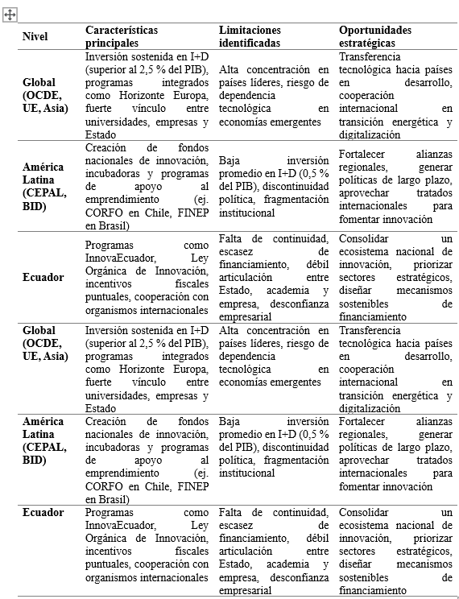

Note: Prepared by the author based on data from the OECD (2021), ECLAC (2020), the World Bank (2021), and Hidrobo-Morales, Paredes, and León (2024).

The comparison shows that, while in the Organization for Economic Cooperation and Development (OECD) OECD and Asia, investment in research and development exceeds 2.5% of GDP and is sustained over time, whereas in Latin America it barely reaches 0.5%, reflecting a structural gap (ECLAC, 2020; OECD, 2021). In Ecuador, programs such as InnovaEcuador and the Organic Law on Innovation have led to progress, but their impact has been limited by a lack of continuity and poor institutional coordination (World Bank, 2021; Hidrobo-Morales et al., 2024). This contrast confirms that countries with sustained policies succeed in consolidating stable ecosystems, while in fragile contexts, progress is diluted by changes in government.
Assessment of Weaknesses and Opportunities
To examine the Ecuadorian case in greater depth, Table 2 presents an analysis of the main weaknesses and opportunities across four dimensions: institutional, economic, business, and socio-environmental.

Table 2. Weaknesses and Opportunities for Innovation in Ecuador
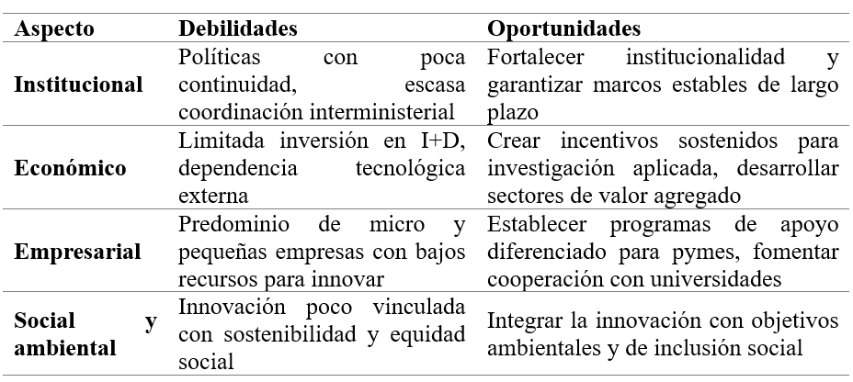
Note: Prepared by the author based on data from ECLAC (2020), the World Bank (2021), the OECD (2021), and Hidrobo-Morales, Paredes, and León (2024).

The table shows that the most significant weaknesses center on a lack of institutional continuity, low investment in R&D, and technological dependence. At the same time, opportunities have been identified, such as strengthening institutional frameworks, creating sustained incentives for applied research, and integrating innovation with social and environmental objectives (World Bank, 2021; ECLAC, 2020). This confirms that, although the landscape is complex, there is room for action if long-term policies are established and mechanisms are designed that recognize business heterogeneity.
Visual Analysis of the Ecosystem’s Dimensions
Furthermore, Figure 1 graphically represents the comparative intensity of weaknesses and opportunities, while Figure 2 shows a heat map illustrating the concentration of challenges and potential.

Figure 1. Comparative Intensity of Weaknesses vs. Opportunities

Source: Prepared by the authors based on an analysis of the dimensions of Ecuador’s innovation ecosystem.

Figure 1 illustrates the comparative intensity of weaknesses and opportunities across the main dimensions of Ecuador’s innovation ecosystem. At the institutional level, there is a high score for weaknesses (4.2), associated with a lack of policy continuity and weak inter-institutional coordination; however, opportunities score 4.0, suggesting that there is still room to strengthen institutional frameworks and design stable, long-term policies.
In the economic sphere, the gap between weaknesses (4.5) and opportunities (3.8) is the most pronounced, reflecting critical problems such as low investment in research and development and dependence on foreign technology. This difference confirms that the economic dimension constitutes one of the main bottlenecks for the advancement of innovation in the country, consistent with the findings of the Economic Commission for Latin America and the Caribbean (2020).
Meanwhile, in the business dimension, there is a balance between weaknesses (4.0) and opportunities (4.2). This reflects that, while the business structure is dominated by micro and small enterprises with limited resources for innovation, there are also favorable conditions for fostering cooperation with universities and designing tailored support programs. In this regard, the business sector appears to have transformative potential if effective promotion policies are implemented.
Similarly, it is worth noting that in the socio-environmental dimension, opportunities (4.5) clearly outweigh weaknesses (3.6), revealing that innovation linked to sustainability and social equity is one of the areas with the greatest potential for Ecuador. This finding aligns with recent studies that highlight the importance of green and social innovation as drivers of future competitiveness (UNU-MERIT, 2024).
In this regard, the figure shows that the greatest weaknesses are concentrated in the economic and institutional spheres, while the most notable opportunities lie in the socio-environmental and business spheres. This contrast demonstrates that, although structural barriers persist, there are also strategic areas from which the transformation of the national innovation ecosystem can be driven.

Figure 2. Heat map: intensity by dimension (0–5)

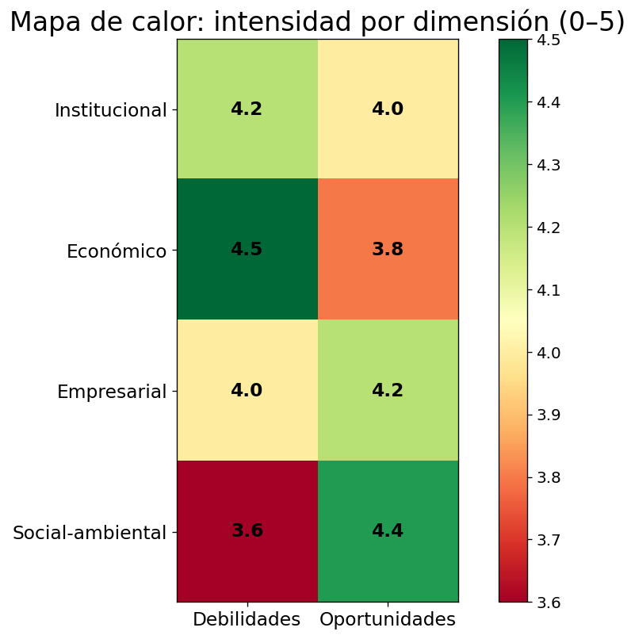
Source: Prepared by the authors based on a comparative analysis of weaknesses and opportunities in Ecuador’s innovation ecosystem.

Figure 2 presents a heat map that contrasts weaknesses and opportunities across the dimensions of Ecuador’s innovation ecosystem. The results show that the greatest weaknesses are concentrated in the economic (4.5) and institutional (4.2) dimensions, reflecting critical problems such as low investment in research and development, dependence on foreign technology, and a lack of continuity in public policies. In contrast, opportunities in these areas appear limited, especially in the economic dimension (3.8), confirming that these dimensions constitute the system’s main critical nodes (ECLAC, 2020).
On the other hand, the business and socio-environmental dimensions exhibit greater potential for transformation. The business dimension shows a balance between weaknesses (4.0) and opportunities (4.2), which opens up possibilities for strengthening cooperation between businesses and universities through targeted support policies. Even more relevant is the socio-environmental dimension, where opportunities (4.4) far outweigh weaknesses (3.6), indicating that sustainability and social inclusion can become strategic drivers of innovation, in line with trends in green and social innovation (United Nations University – Maastricht Economic and Social Research Institute on Innovation and Technology, [UNU-MERIT], 2024).
Semantic Network and Interconnections Among Actors
Figure 3 illustrates a semantic network of relationships within Ecuador’s innovation ecosystem.
Figure 3. Semantic network of relationships in Ecuador’s innovation ecosystem.

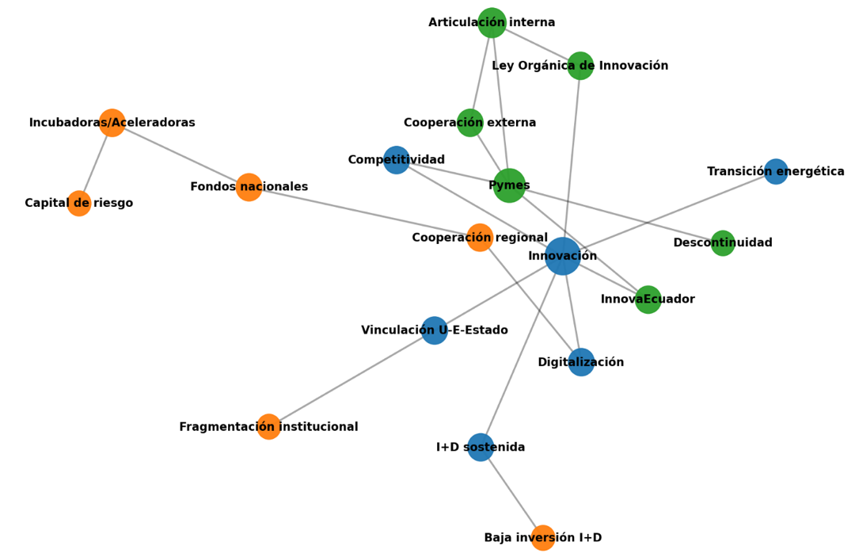
Source: Prepared by the authors based on an analysis of stakeholders, instruments, and critical factors related to national innovation policy.
Figure 3 depicts a semantic network of relationships that links key concepts within Ecuador’s innovation ecosystem; with innovation as the central node, from which connections extend to strategic actors, specific policies, structural barriers, and priority sectors. The colors help distinguish different types of elements: blue represents structural factors and strategic objectives such as digitalization, the energy transition, and competitiveness; green represents institutional actors and programs such as InnovaEcuador, SMEs, and the Organic Law on Innovation; while orange represents the most common obstacles, such as low investment in research and development, discontinuity, or institutional fragmentation. This diagram helps illustrate the system’s complexity and shows how the various elements do not operate in isolation but within a network of relationships that either reinforce or hinder one another.
Based on this visualization, it is possible to identify courses of action to strengthen the system. For example, the connection between innovation and digitalization presents opportunities for productive transformation if accompanied by sustained investment. Similarly, the link between venture capital and incubators highlights the importance of creating financial environments that do not exclude small businesses, It also shows how certain obstacles have cross-cutting effects—such as institutional discontinuity or fragmentation—which weaken multiple key connections. Taken as a whole, this map not only illustrates the structure of the current ecosystem but also allows us to envision more coordinated interventions that aim not merely to correct specific flaws but to redesign the system based on a logic of complementarity among actors,
Furthermore, to organize the findings from the literature review more clearly, the concepts associated with innovation were systematized across three levels: global, regional (Latin America), and national (Ecuador). To this end, a comparative table was created to identify the characteristic elements of each level.

Table 3. Comparison of Innovation Concepts
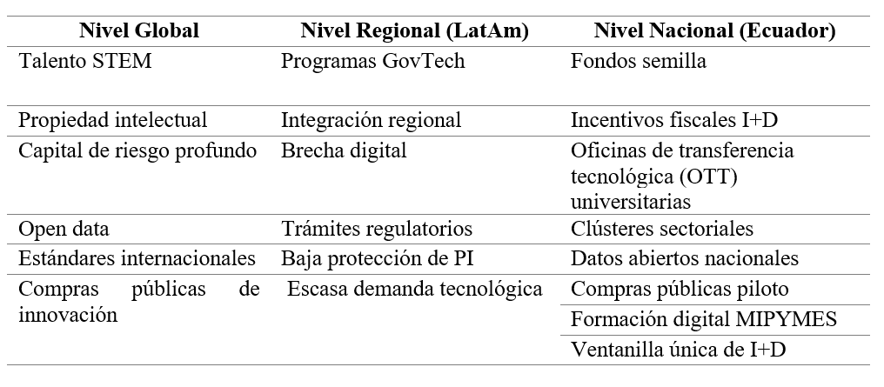
The comparative table shows that, while concepts of high technological sophistication—such as deep-pocket venture capital or international standards—predominate at the global level, structural challenges such as the digital divide and weak intellectual property protection emerge at the regional level. In the case of Ecuador, the identified elements reflect an intermediate stage in which operational instruments (seed funds, sectoral clusters, or pilot public procurement programs) have been developed, although these have not yet succeeded in establishing a robust ecosystem. This contrast highlights the gap between global agendas and local capacities, confirming the need to design policies that effectively translate international standards into mechanisms applicable to the national context.
The research findings confirm that Ecuador’s innovation ecosystem faces significant structural barriers at the institutional and economic levels, in line with the arguments put forward by Huang (2024), who highlights that a lack of funding and inter-institutional coordination limits the effectiveness of national innovation systems in middle-income countries. The discontinuity of public policies, institutional fragmentation, and low investment in research and development (barely 0.5% of GDP on a regional average) constitute critical bottlenecks that restrict the development of innovation capabilities, as also noted by the Economic Commission for Latin America and the Caribbean (2020).
Nevertheless, the results show that the entrepreneurial and socio-environmental dimensions represent strategic areas of opportunity. The existence of initiatives such as seed funds, tax incentives, and sectoral clusters in Ecuador suggests that, although the system is still in its infancy, there is room to foster innovation through tailored policies aimed at micro, small, and medium-sized enterprises. These findings are consistent with Hamdouna (2025), who highlights innovation as an indispensable condition for the sustainable competitiveness of organizations, especially in highly vulnerable environments.
Furthermore, the positive outlook observed in the socio-environmental dimension aligns with the global trend toward green and social innovation. Recent studies indicate that incorporating sustainability and social inclusion into innovation policies not only strengthens competitiveness but also builds resilience in the face of climate and socioeconomic crises (UNU-MERIT, 2024). This finding represents a strategic advantage for Ecuador, a megadiverse country whose biodiversity and cultural wealth can become drivers of contextualized innovation with its own distinct identity.
Consequently, the multiscale comparison and semantic analysis reveal a gap between global agendas and national capacities. While concepts such as deep-tech venture capital, international standards, and intellectual property predominate at the international level, efforts in Ecuador focus on operational mechanisms such as seed funds, pilot public procurement programs, or one-stop R&D windows. This disconnect, also observed by Fernández-Sastre (2024), shows that innovation in Ecuador depends largely on the partial adaptation of external initiatives, which limits its autonomy and long-term sustainability. The discussion thus raises the need to design policies that not only translate international standards but also build a distinct ecosystem that is well-coordinated and consistent with national particularities.

CONCLUSIONS

An analysis of documents and public policies confirms that innovation is neither an isolated process within companies nor the exclusive result of private initiatives or well-drafted regulations. Rather, it is a complex network of relationships, agreements, and institutional conditions that require continuity over time. Within this framework, laws are important, but so too are the government’s management capacity, budgetary commitment, international cooperation, and—crucially—trust among actors who have traditionally operated in a fragmented manner. A comparison between leading countries, Latin America, and the case of Ecuador reveals clear contrasts: while in the former, innovation is consolidated through stable and sustained policies, in Ecuador, efforts remain scattered and lack strategic coordination.
The results highlight a constant tension between national aspirations and capabilities. On the one hand, structural gaps persist, such as policy discontinuity, low investment in research and development, and mistrust among institutions. On the other hand, opportunities are emerging that should not be underestimated: incentives that can be redesigned, institutions that could be strengthened, and international cooperation that provides funding and accumulated knowledge. The experiences of other countries in the region show that progress is possible when there is a commitment to long-term planning and the logic of improvisation is overcome.
The visual tools used (comparative tables, heat maps, and semantic networks) made it clear that innovation is a multidimensional phenomenon that cannot be reduced to economic factors alone, as it also involves social, environmental, and cultural dimensions. These representations confirmed that Ecuador still relies excessively on external drivers and has not managed to consolidate a solid internal alliance among the government, academia, and the business sector. Unless these actors coordinate their efforts around common, far-reaching objectives, progress will remain partial and difficult to sustain.
Consequently, innovation in Ecuador must be understood as an unfinished project that can still take shape if the identified weaknesses are addressed as concrete challenges rather than insurmountable obstacles. It is not enough to recognize opportunities; it is essential to sustain them over time, shield them from political volatility, and protect them from institutional fragmentation. If innovation becomes a collective practice—beyond mere rhetoric—the country will be able to move toward a competitive, inclusive, and sustainable development model, where innovating means not only achieving economic growth but also ensuring social equity and environmental sustainability.
In this way, the study met its stated objective by critically analyzing policies and documents related to innovation in Ecuador’s business sector, which made it possible to identify both priority areas for intervention (institutional and economic) and strategic, business, and socio-environmental opportunities. These findings confirm that innovation in the country must be conceived as a long-term state policy, with stable funding and effective coordination mechanisms among the government, academia, and the business sector, in order to establish itself as a true driver of competitiveness, social inclusion, and sustainability.

REFERENCES
Agazu, B. G., Adu-Gyamfi, G., Donkor, J., & Sakyi, H. (2024). Innovation strategy and firm competitiveness: A systematic review. Journal of Innovation and Entrepreneurship, 13(22), 1–18.
Álvarez, R., Grazzi, M., Suárez, D., & Vergara, S. (2024). Innovación y emprendimiento en América Latina: Evidencia reciente y desafíos. Estudios de Economía, 51(1), 5–17.
Arias, F. (2012). El proyecto de investigación: Introducción a la metodología científica (6.ª ed.). Caracas: Episteme.
Banco Mundial. (2021). Ecuador innovation and value chains report.
Banco Mundial. (2021). Ecuador innovation and value chains report. World Bank Group.
Brás, G. R. (2024). National innovation systems and sustainable environmental performance. Sustainable Innovation Review, 4(2), 55–72. https://doi.org/10.1016/j.susir.2024.100144
CEPAL. (2020). La inversión en investigación y desarrollo en América Latina y el Caribe. Naciones Unidas. Comisión Económica para América Latina y el Caribe. (2020). La inversión en investigación y desarrollo en América Latina y el Caribe. Naciones Unidas.
Fernández-Sastre, J. (2024). The geographical component in firms’ perception of innovation barriers in Ecuador. Journal of Business Research, 164, 113–125.
GIZ Ecuador. (2023). Fomentar el ecosistema nacional de innovación en Ecuador. Deutsche Gesellschaft für Internationale Zusammenarbeit.
Hamdouna, M. (2025). Technological innovations are key determinants of the sustainable competitiveness of economic entities. Sustainability, 17(5), 1953.
Hernández, R., Fernández, C., & Baptista, M. (2018). Metodología de la investigación (6.ª ed.). Ciudad de México: McGraw-Hill.
Hidrobo-Morales, A., Paredes, J., & León, M. (2024). Analysis of innovation drivers with a mapping innovation approach: Practical application in Ecuador. Journal of Innovation and Entrepreneurship, 13(22), 1–15.
Huang, X. (2024). Five elements of national innovation systems and innovation performance: A fsQCA comparison of high-income and middle-income economies. Humanities and Social Sciences Communications, 11(1), 569.
Li, X. (2023). Knowledge-based dynamic capabilities in national innovation systems and sustainability. Journal of Innovation & Knowledge, 8(4), 100235.
Organización para la Cooperación y Desarrollo Económico [OCDE]. (2021). OECD science, technology and innovation outlook 2021: Times of crisis and opportunity. OECD Publishing.
Organización para la Cooperación y Desarrollo Económico. (2021). OECD science, technology and innovation outlook 2021: Times of crisis and opportunity. OECD Publishing.
United Nations University – Maastricht Economic and Social Research Institute on Innovation and Technology. (2024). Green technological innovation in South America.
UNU-MERIT Research Highlights. UNU-MERIT. (2024). Green technological innovation in South America.
World Bank. (2023). Services and innovation for economic transformation in Ecuador.

* Orcid: https://orcid.org/0000-0002-0188-6275 Universidad Técnica Luis Vargas Torres de Esmeraldas - Ecuador Correo: fanny.egas@utelvt.edu.ec Orcid: https://orcid.org/0000-0001-8689-7274 Universidad Técnica Luis Vargas Torres de Esmeraldas - Ecuador Correo: emma.salazar@utelvt.edu.ec Orcid: https://orcid.org/0009-0003-8364-8370 Universidad Técnica Luis Vargas Torres de Esmeraldas - Ecuador Correo: jair.cheme.hernandez@utelvt.edu.ec Orcid: https://orcid.org/0009-0008-2301-6423 Universidad Técnica Luis Vargas Torres de Esmeraldas - Ecuador Correo: marelyn.masapanta.delgado@utelvt.edu.ec

